Our Mission: To bring Nevadans together to promote barrier-free communities in which individuals with disabilities have access to opportunities for quality work and self-sufficiency.

Nevada VR provides vocational rehabilitation services to eligible individuals with disabilities to prepare for and obtain meaningful competitive employment, consistent with their skills, abilities and informed choice.

Nevada VR works closely with Nevada’s businesses to fulfill employers’ needs for trained and skilled employees in any area of commerce. Additionally, we work collaboratively with other public and private entities to utilize experience, resources and expertise to best serve individuals with disabilities and employers.

Nevada VR assists students with disabilities to successfully transition from secondary school to work or higher education. We also provide follow-up services to employers and participants to ensure the satisfaction of both parties.

Nevada VR specializes in services tailored to meet the individual needs of persons with disabilities, including:
Nevada VR administers the Supported Employment Program to expand employment options for individuals with the most significant disabilities through intensive training, supervision and other vocational rehabilitation services.

VR Facts for FFY16:

❖ 5,169 Participants Served

❖ 897 Individuals Closed With Employment

❖ $11.99 Average Hourly Wage

❖ $429,460 Reimbursed by SSA for

SSI / SSDI Recipients

Top Five Job Titles Achieved by Participants:

☑ Sales and Service Workers
☑ Stock and Material Movers
☑ Clerical / Administrative Support
☑ Food Service Workers
☑ Health Care / Medical Industry

☑ Transportation
☑ Assistive Technology
☑ Counseling and Guidance
☑ Job Development and Placement

Primary Disability Breakdown

Visual
5%

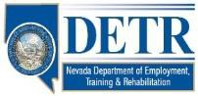☑ Occupational and Vocational Training

Please Contact Us At:
751 Basque Way Carson City, NV 89706 (775) 687-6860 sghendren@nvdetr.org

Mental
58%
Hearing
17%

Physical
20%

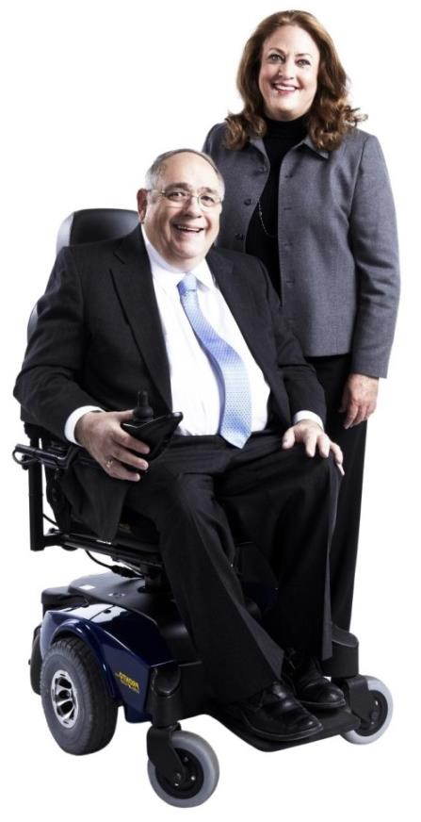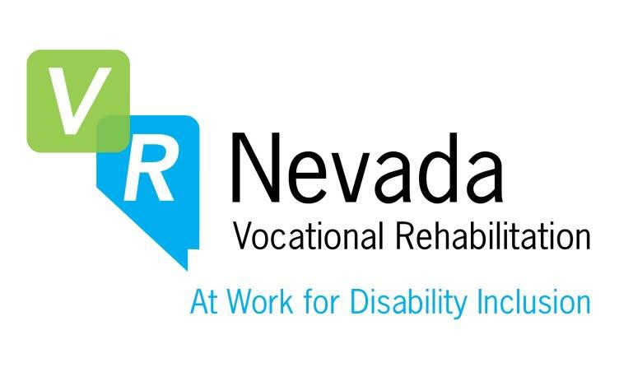jajohn@nvdetr.org

Or Visit Us Online At: www.nvdetr.org www.vrnevada.org
Search ‘VR-Nevada’ on
Facebook, LinkedIn, YouTube and Twitter

