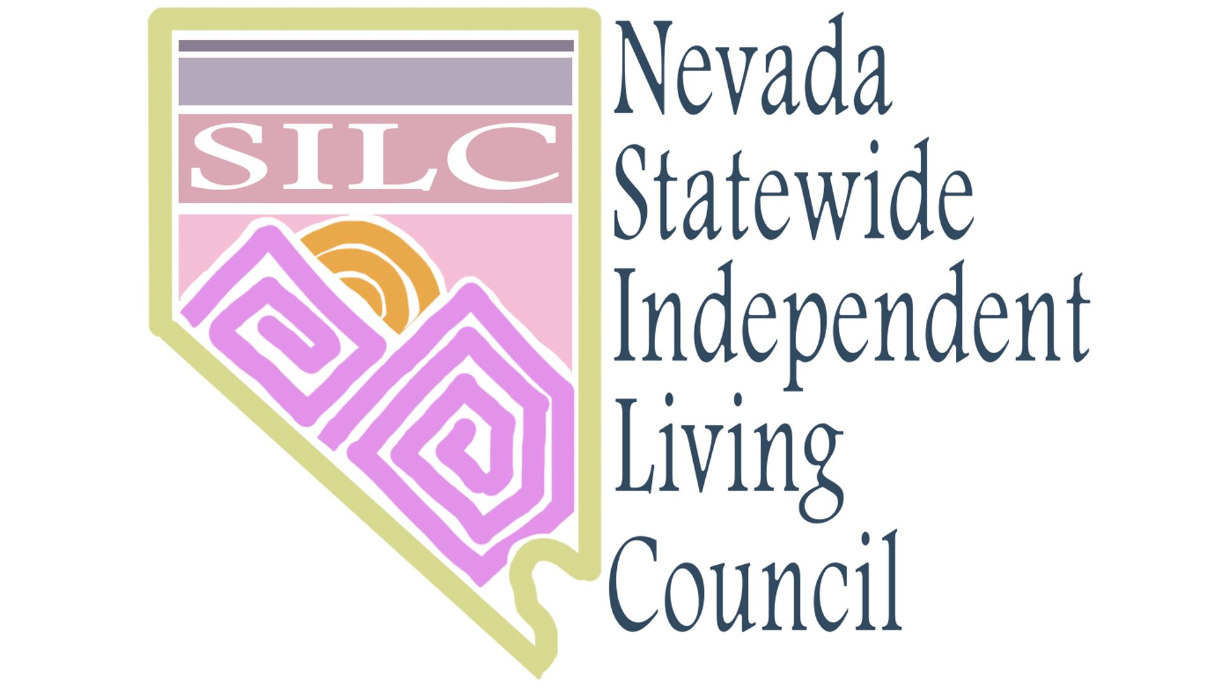

Nevada SILC Policies and Procedures Manual
  - Rev. 4/9/2020

NV SILC  PO Box 33386  Las Vegas, NV 89133 |  | p. (702) 486-5940 |  | nvsilc@adsd.nv.gov  http://adsd.nv.gov/Boards/SILC/SILC/  Website - http://NVSILC.com

Table of Contents
- Policies and Procedures Summary 2
- NV SILC: What We’re About 3
Objective
Mission Statement
Vision Statement

- Purpose of the Nevada SILC 5

- Policies and Procedures 6+
Recruitment
Disputes / Conflicts of Interest
Official Meetings
Accommodations
State Plan for Independent Living (SPIL) Development and Implementation
Eligibility of the Centers for Independent Living (CIL) for SPIL Inclusivity
Code of Ethics and Meeting Etiquette
Hiring and Evaluation of Staff

Policies and Procedures Summary
The Nevada Statewide Independent Living Council (SILC) is an autonomous entity that encompasses the entire State providing advocacy and support for Independent Living services throughout. It consists of a group of volunteers appointed by the Governor that consists of a majority of individuals with disabilities in order to have a strong consumer voice moving forward. Individuals with disabilities of all types are supported by the Nevada SILC’s Mission and Vision.
The IL Program is funded primarily through the federal Rehabilitation Act (Independent Living Part-B) and a portion of matched State general funds. The Aging and Disability Services Division AT/IL manual provides policy and guidance for program operations. All services provided by ADSD grantees must be in compliance with Service Specifications, which are found at http://adsd.nv.gov/uploadedFiles/adsdnvgov/content/Programs/Grant/ServSpecs/GeneralServiceSpecsDSPrograms.pdf and fiscal instructions called PINs – Program Instructions Nevada, found at http://adsd.nv.gov/uploadedFiles/agingnvgov/content/Programs/Grant/nvpins.pdf. They must also agree to Assurances and Certifications, and the agency’s Confidentiality Agreement.
This Policy and Procedure manual is meant to compliment the Designated State Entity guidelines by addressing specific expectations of Council members in Nevada, according to Nevada law and the Nevada SILC’s authority.

NV SILC – What We’re About

SPIL Objectives

Objective A: To realign, build and promote an autonomous NVSILC.

Objective A1:

Research and review other states to understand various ways SILCs are set up and use as an aid towards determining the best establishment for NVSILC.

Objective A2:

Research all applicable federal, state and local laws that pertain to independent living services to gain a thorough working knowledge for successful movement towards autonomy.

Objective A3:

Provide a series of on-going trainings to increase competencies of the NVSILC and community partners

Objective A4:

Develop a working relationship with the Governor’s office to strengthen NVSILC's composition and to ensure a majority of its voting members represent a cross section of disabilities.

Objective A5:

Conduct an organizational assessment of the NVSILC and its compliance assurances to understand the strengths and weaknesses of NVSILC and make improvements where necessary.

Objective A6:

Draft a strategic business plan to strengthen and move the NVSILC towards autonomy.

Objective B: Support a comprehensive statewide network of Center for Independent Living services.

Objective B1:

NVSILC and CIL’s will collaborate to address priority needs within the state.

Objective B2:

Ensure effective communication between the NVSILC and CIL’s.

Objective C: Develop a comprehensive statewide independent living network (SILN).

Objective C1:

The NVSILC and the CIL’s will collaborate with programs and services throughout the state to develop a comprehensive statewide independent living network.

Objective C2:

Develop strategies to increase awareness of the IL Philosophy, by working with community partners, CIL’s and the statewide independent living network.

Objective D: Develop data collection process.

Objective D1:

Research and develop an effective data collection strategy.

Objective D2:

Implement data collection strategies and review annually. Explore partnerships with other agencies and community partners to develop a viable data collection tool.

Mission Statement
The mission of the Council is to advocate for the development of a network of programs, services and options designed to empower Nevadans with disabilities to live independently in the community.

Vision Statement
The Nevada SILC collaborates to create a community that values respect, equality and self-direction throughout the State.

Purpose of the Nevada SILC
The specific purposes of the Council is:
1. to promote the philosophy of independent living, including a philosophy of consumer control, peer support, self-help, self-determination, equal access and individual and system advocacy in order to maximize the leadership, empowerment, independence, and productivity of individuals with disabilities, and the integration and full inclusion of individuals with disabilities into the mainstream of society;
2. to promote the development and expansion of independent living programs and concepts on a statewide basis;
3. to provide guidance to State agencies and local planning and administrative entities assisted pursuant to Title VII of the Act;
4. to provide guidance to State agencies and local planning and administrative entities that are providing independent living services; and
5. to improve working relationships among councils, centers for independent living, State, federal and non-federal programs.

Policies and Procedures

Recruitment
Procedure:
Each potential new member will be assigned to a designated mentor
Each of the following will be available to the prospective new member in hard copy, online or in the accessible format needed:
1. SILC Fact Sheet
2. SILC booklet brochure
3. Membership Checklist of requirements
4. IL vs. Medical model sheet
5. CIL information
6. Membership Table
Ideally, each potential new member will attend SILC and/or SPIL Workgroup Meetings prior to appointment.
After working closely with the mentor, the mentor will present a recommendation for membership appointment to the Nominating Committee.
Once approval from the Nominating Committee moves forward, the New Membership packet will be provided, including the new member checklist of training activities.
Final Approval of endorsement for membership will be decided at the next SILC Meeting.

Policy:
The assigned mentor, if possible, will forward the application for Council membership to the Chairperson within 10 business days of submission to the Governor’s Office.
The NV SILC Chairperson will review potential membership applications within 2 weeks of receipt from mentor.
The Council shall vote to approve endorsement of membership for only those individuals who meet the required Federal Membership Composition Guidelines for the Council per Article V in the NV SILC Bylaws.

Disputes / Conflict of Interest
Regarding any potential conflict of interest:
All Council Members shall abstain from conduct that would be deemed as a conflict of interest as outlined in the Nevada SILC bylaws, as well as any consequences arising from occurrences.
Disputes:
Regarding Removal of Council Members:
If any member has two or more consecutive absences from a pre-scheduled meeting, that person will be notified that they are no longer participating members of the Council, and the recommendation for removal as a Council member will be forwarded to the Governor’s Office.
If any violation of the code of ethics occurs, the Chair, the DSE Representative, and the Executive Director of the Council will hold a private meeting to determine the severity of the offense. They may or may not be in succession.
Mild or 1st Offense – Chair, Executive Director and/or DSE Representative will inform the individual of their offense in writing (this may be e-mail format), and documentation will be held for a period of one year.
Moderate or 2nd Offense – Chair, Executive Director and/or DSE Representative will inform the individual of their noted offense in writing (this may be e-mail format), and documentation will be held for a period of one year. If another offense has been documented within one year prior, the first offense documentation will be re-held for another period of one year to start in succession with the second offense documentation. The individual receiving the second offense will be informed it is his/her second offense in a year.
Severe or 3rd Offense – Chair, Executive Director and DSE Representative will communicate to the individual the terms of their Council removal, in accordance with any contracts held by the offender with the Nevada SILC or the DSE.
Resignation of Council Members:
In the event a Council member wishes to resign, the individual shall submit a letter of resignation to both the Chair and the DSE Representative along with the preferred effective date and a brief description of the reason for resignation. If no date is provided, resignation will be assumed immediate.

Official Meetings
All official Council and Committee Meetings will be planned, posted, and held according to Nevada Open Meeting Law requirements.
The SILC shall meet at least quarterly according to Federal guidelines (45 CFR 1329.15(a)(3)).

Accommodations
The Nevada SILC is pleased to make reasonable accommodations for any individual who has a disability(s) and wishes to attend a meeting. If special arrangements for the meeting are necessary, please notify the Aging and Disability representative listed on the http://adsd.nv.gov/Boards/SILC/SILC/ website as soon as possible and at least ten business days in advance of the meeting. If you wish, you may e-mail the NV SILC at NVSILC@adsd.nv.gov. Supporting materials for meetings are available at: 3416 Goni Road, #D-132, Carson City, NV 89706 or by contacting the above as referenced.

State Plan for Independent Living (SPIL) Development and Implementation
Town Hall Meetings will be arranged according to Nevada Open Meeting Law at least 6 months in advance of SPIL planning; at least one month prior to submitting the SPIL for approval to the ACL; and at other times as deemed necessary by the SILC or SPIL Workgroup to provide an accurate representation of public needs.
The Nevada SILC will continuously work to improve the process for developing the SPIL.
The Nevada SILC will monitor, review, and evaluate the current SPIL Objectives at least quarterly.

Eligibility of Centers for Independent Living (CIL) for SPIL Inclusivity
According to 45 CFR 1329.17(d)(2)(iii), not less than 51% of CIL’s will participate in the development and approval of the SPIL. All participating CIL’s must be willing to share proof of their Part C approval, upon request by the SILC.

Code of Ethics and Meeting Etiquette
All new members will agree to a Code of Ethics form that states the following:
Nevada Statewide Independent Living Council
Code of Ethics
1. I will uphold and enforce all laws, rules and regulations that apply to
recipients of federal funds and to the SILC.

2. I will make decisions that assure the equal access and independent
living of people with disabilities and will seek to develop, support and maintain
Independent Living Services.

3. I understand that the role of the board is policy making, planning, and
appraisal, and I will help to frame policies and plans only after the
Council has consulted those who will be affected by them.

4. I will carry out my responsibility, not to interfere with the day to day
operations of the Center and/or SILC, but, together with my fellow
Council members, to only hire qualified staff, if applicable.

5. I recognize that authority rests with the Council as a whole, and will
make no individual promises nor take any private action that may compromise
the Council.

6. I refuse to surrender my independent judgment to special interest or
partisan political groups or to use the Council position for personal
gain or for the gain of friends or family.

7. In all activities and decisions of this Council, I will act in respect for
all people, and will assure that the rights and dignity of others are
upheld. I will not bully, threaten or intimidate any other Council member or
stakeholder either during a meeting or outside of meetings.

8. I will refer all complaints to the SILC Chair, Vice-Chair and/or DSE and will
act on the complaints from the public only after failure of an
administrative solution.

Signature: __________________________ Date: _________________
Printed Name: ___________________________________

Evaluation of Staff
In the event a new Executive Director must be hired under State employment, the Council Chair, Vice Chair, and DSE Representative will be members of the interview panel and will make the final determination regarding who will be hired for the position. In the event the Chair or Vice Chair is unavailable to participate in the hiring process, another Council member may serve on their behalf.
Each year, during the month of February, the Executive Director (ED) will be evaluated according to established work performance standards (WPS) that have been agreed upon by the Chair, Vice-Chair, Executive Director, and staff supervisor through State employment. These signatures shall be in effect for as long as the work performance standards do not change for the ED. If any changes are made at any time, new signatures will be documented to establish agreement with all work performance standards/expectations.
The ED may not be evaluated unless designated parties are all in agreement with established WPS. The evaluation will include reasonable goals to ensure growth and improvement according to the established job elements in the WPS. This written evaluation will be kept confidential from all other parties, including the public, and maintained by the DSE in a personnel file designated to the staff person named as Executive Director. This may be made available to the current Chair and/or Chairperson of the NV SILC, and/or the DSE representative as requested, but will not be shared with any other parties at any time. By accepting the authoritative positions named in this process, you agree to these terms for purposes of confidentiality. The only other person who may access these records is the named staff person on file serving in the role as Executive Director.

