Dementia Friendly Nevada
ADSD-Sponsored Community Action Groups

Request for Proposals

Introduction
The statewide Dementia Friendly Nevada initiative is requesting proposals to launch seven (7) community action groups funded through a federal grant that was recently awarded to the Nevada Aging and Disability Services Division (ADSD). The purpose of the initiative is to: 1) engage Nevada communities, including persons living with dementia, family care partners, healthcare professionals and the broader community, in dialogue about Alzheimer’s disease and other forms of dementia; 2) foster a collaborative, multi-sector approach toward becoming a dementia friendly and inclusive community using the Dementia Friendly America model; and 3) expand the reach of the Nevada Dementia Supports Toolbox. As a result, this initiative aims to develop and promote communities that are informed, safe, respectful and inclusive of persons living with dementia and their care partners.

Objective 1: Initiate community action groups in seven (7) targeted areas across the state aimed at transforming the culture of dementia in those communities, enabling conversation and participation by all citizens, especially persons living with dementia.
- Develop three (4) community action groups in 2017 and four (3) community action groups in 2018, with support from the following ADSD grant partners through September 2019:
  - Capacity-building (co-)facilitation support from Jennifer Carson, PhD, Research Assistant Professor, Community Health Sciences, UNR
  - Evaluation support from the Sanford Center for Aging, UNR
  - Program and technical assistance from a Resource Development Analyst, ADSD

Objective 2: Facilitate and mobilize community-driven change utilizing the Dementia-Friendly America model.
- Each community action group will identify and launch at least two (2) community goals to promote a dementia friendly and inclusive community using the Dementia Friendly American toolkit, available online (http://www.dfamerica.org/), which guides communities through four (4) phases of engagement, planning, goal-setting, and implementation:
  - Phase 1: Convene a community action group comprised of key community leaders and members to better understand Alzheimer’s disease and other forms of dementia and their implications for the community.
  - Phase 2: Assess current strengths and gaps in meeting the needs that result from Alzheimer’s disease and other forms of dementia, using a comprehensive community assessment.
  - Phase 3: Analyze community needs and determine which issues stakeholders are motivated to act on; then set at least two (2) community goals.
  - Phase 4: Act together to establish implementation plans for your goals and identify ways to measure progress.
Objective 3: Enhance the reach of programs within the Nevada Dementia Supports Toolbox.
- Each community action group will refer community members to evidence-based programs within the Nevada Dementia Supports Toolbox, which include:
  - Benjamin Rose Institute on Aging Care Consultation (BRI/CC): offers assistance and support to individuals with chronic conditions and their care partners by telephone and email
  - Care Partners Reaching Out (CarePRO): a series of skill-building workshops for family care partners that focus on stress management and communication
  - Early-Stage Partners in Care (EPIC): a workshop for people living with early-stage memory loss and their care partners to reduce stress, enhance well-being, and manage challenges
- Community action groups will also identify three (3) to four (4) gap areas in existing programs and services, and the Lou Ruvo Cleveland Clinic for Brain Health will work to identify or develop new programs and services to address these gaps.

Dementia Friendly Nevada Statewide Coordination and Collaboration

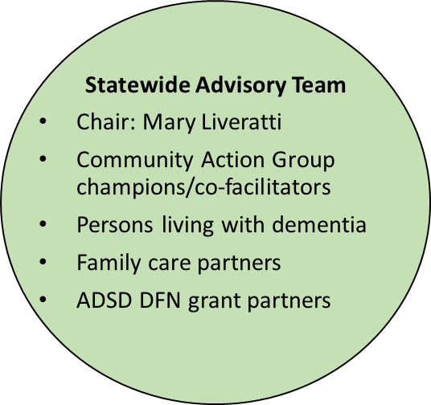
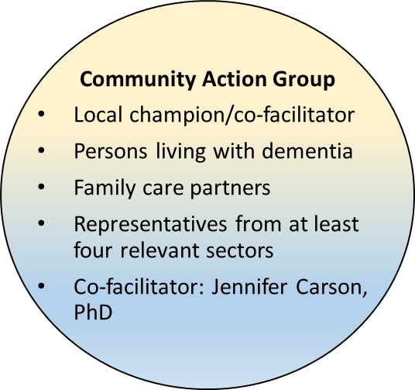
Application Instructions

Funding (Amount, Use and Period)
- Award range: up to $10,000 per year for one (1) or two (2) years
- Grants will be awarded to participating community action groups to support priority goal implementation and other approved Dementia Friendly Nevada activities.
- The ADSD grant also covers the costs associated with (co-)facilitation support, evaluation support, and program and technical assistance.
- Funding awards are intended for use by the selected applicants to initiate and implement their process. The first round of funding was awarded to applicants July 1, 2017. Through this funding opportunity, applicants will be awarded in March 2018.

Selected partners will ensure the project fills service gaps identified in the following four areas.
- Provision of effective supportive services to persons living alone with ADRD in the community;
- Provision of effective care/supportive services to persons living with moderate to severe impairment from ADRD and their caregiver;
- Improvement of the quality and effectiveness of programs and services dedicated to individuals aging with intellectual and developmental disabilities with ADRD or those at high risk of developing ADRD;
4. Delivery of behavioral symptom management training and expert consultation for family caregivers.

Eligible Applicants
Funding awards can be made to non-profit organizations with 501c (3) status or their fiscal agents and to governmental units. It is expected that one organization will apply on behalf of a community action group. ‘Communities’ can be defined as geographic, such as a city or cities, or as one of affinity, such as a faith community. While for-profit organizations are not eligible to receive funding, they should be represented and participate in community action groups. Community action groups will be selected from both urban and rural areas. Applicants must demonstrate the following to be considered for funding:
- Demonstrated community interest in becoming dementia friendly and inclusive
- Identified champion/co-facilitator who will also report to the Statewide Advisory Team
- Commitment to include persons with dementia and family care partners in the community action group
- Participation from representatives from at least four (4) relevant sectors, including:

- Memory Loss Supports and Services
- Community Based Services and Supports
- Banks and Financial Services
- Neighbors and Community Members
- Hospitals
- Communities of Faith
- Health Care Throughout the Continuum
- Libraries
- Businesses
- Government, Community and Mobility Planning
- Emergency Planning and First Response
- Legal and Advanced Planning Services

Commitment to Evaluation
In order to demonstrate to ourselves, ADSD and our federal sponsor that the use of these funds helped communities achieve their proposed measures of dementia friendliness and inclusivity, the following activities and reporting will be required of selected communities:
- Participation in a quarterly information exchange process among communities involved in the initiative. This will be an opportunity for communities to learn best practices from each other as well as ways to deal with obstacles and challenges. The information exchange will also be open to communities not selected for funding. Most often, the information exchange will take place during Statewide Advisory Team meetings.
- Quarterly reports on progress being made toward achieving goals (a template will be provided)
- Participation in other evaluation activities as identified by the Sanford Center for Aging

Application Process and Timeline
Applications will be accepted via email on or before 4:00 PM on Monday, February 12, 2018.
- The Dementia Friendly Nevada Statewide Advisory Team will review, score, and announce the successful proposals for funding in March, 2018.
- ADSD will work with each grantee to develop a Memorandum of Understanding (MOU.
- Project implementation may begin once the MOU has been executed.
- Funds must be spent by September 1, 2019.

Application Scoring Criteria
- Each of the questions in Section B (1 – 4) are worth 10 points for a maximum total of 40 points.
- Awarding the maximum number of points is based on:
  - Clarity of the narrative
  - Involvement and support from any identified partners, including persons living with dementia and their family care partners
  - Strengths and assets that will enable the community to move toward dementia friendliness and inclusivity
- Consideration will be given to geographic diversity.

FUNDING APPLICATION

The instructions and application form (in Word) can be downloaded from the Nevada State Task Force on Alzheimer’s Disease website (http://adsd.nv.gov/Boards/TaskForceAlz/TFAD/), or through ADSD’s grant opportunities webpage (http://adsd.nv.gov/layouts/Page_Style_1.aspx?id=62310). If you would like the instructions and application emailed to you, please contact: Jeff Doucet, ADSD, at jsdoucet@adsd.nv.gov

Complete applications will be accepted on or before 4:00 PM on Monday, February 12, 2018.

Please submit the Funding Application Form, which begins on the following page, in Word format using a minimum of 12 point font. Relevant attachments are acceptable but not required.

Email submissions are preferred. Please send your completed application to
ATTN: DF 2018, ADSD, at ADSDGrants@adsd.nv.gov

Other options include mailing to:
Jeff Doucet, MBA, CPM
Management Analyst 3
Nevada Department of Health and Human Services
Aging and Disability Services Division, Resource Development
1860 E. Sahara Ave |Las Vegas, NV 89104
T: (702) 486-3367
APPLICATION FORM

Section A: Contact Information

Applicant/lead agency:

Name or description of community or communities within the project:

Contact person:

Mailing address:

Telephone:

Fax number:

Email address:

Name, address, and signature of person authorized to submit an application for funding and commit the applicant organization to the project:

(The narrative descriptions for Section B should not exceed two (2) single-spaced typed pages in a minimum of 12-point font.)

Section B: Community Readiness Questions

- Can you identify several organizations and individuals, including representatives from at least four (4) community sectors, who are willing to be involved in a community action group to collectively address how to become dementia friendly and inclusive?

Yes: | No: | Maybe, with these conditions/exceptions:

Please describe: (While it is not required, please attach any letters of commitment from potential community action group members)

- Does your community have an influencer/champion who is willing to endorse, kick off and co-facilitate a community action group and serve on the Statewide Advisory Team, and who can help the broader community commit to dementia friendly and inclusive principles?

Yes: | No: | Maybe, with these conditions/exceptions:

Please describe:

- Has your community shown an interest in dementia awareness, dementia capable, dementia friendly, or dementia inclusive initiatives in the past, specifically through involvement in local or regional efforts or related initiatives?

Yes: | No: | Maybe, with these conditions/exceptions:

Please describe:

- The process for becoming dementia friendly takes at least 18 months and is ongoing. With support from ADSD project partners, it engages the community through a community assessment, followed by data analysis and reporting, and then developing and implementing an action plan that addresses at least two (2) dementia friendly goals. Do you believe that with support your group can follow and accomplish this process?

Yes: | No: | Maybe, with these conditions/exceptions:

Please describe:

